1.7.5-ALG checkResume() Algorithm
Purpose:
Validate a resume submission before storing to the Resume data store.

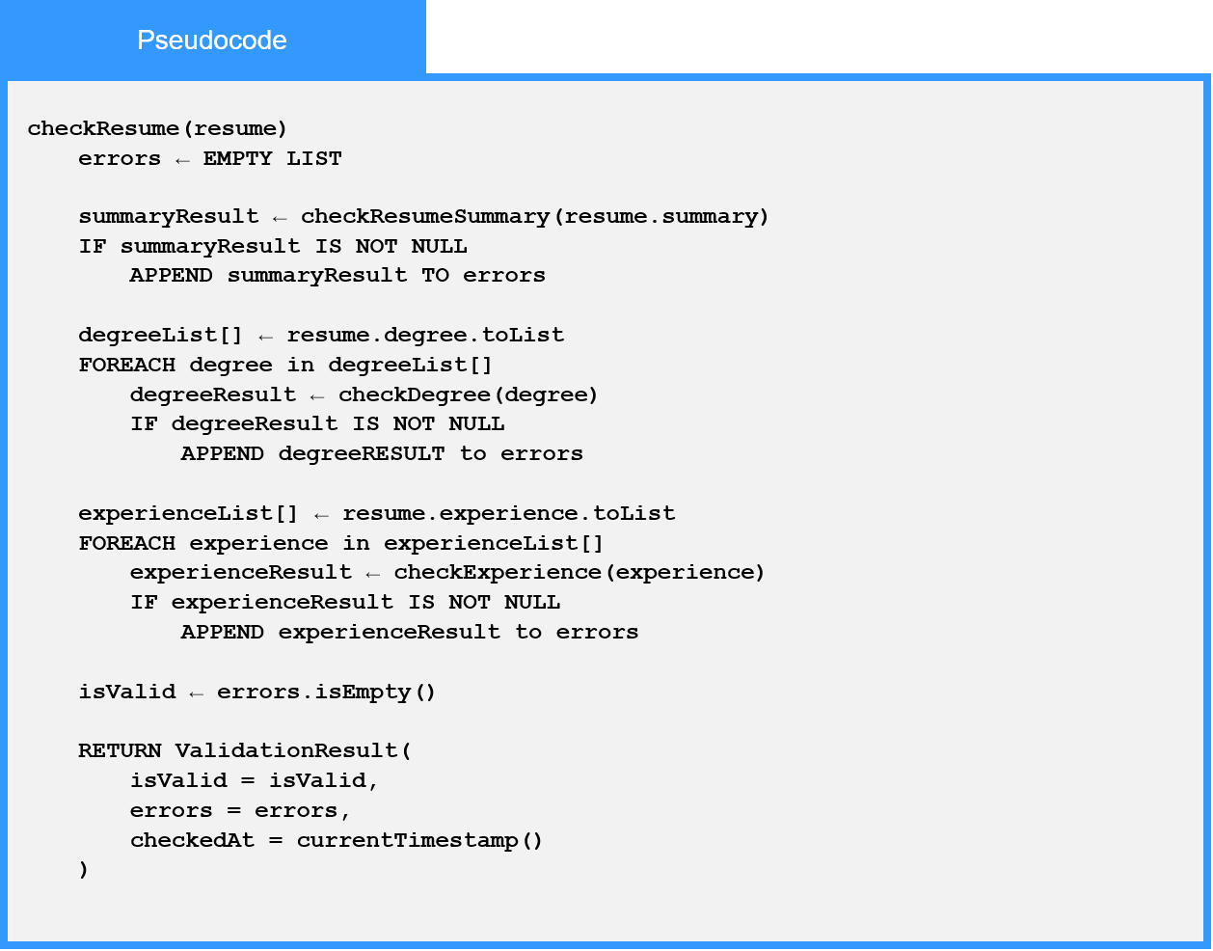
Local Data:
errors : List
summaryResult : Object
degreeResult : Object
experienceResult : Object
ValidationResult : Object

